**APPLIED DATA SCIENCE ASSIGNMENT 2**

**Abstract**The dataset on climate change includes a variety of environmental factors of Veri few countries climate effect of Spyder, a Python module, is used for data visualization. The dataset highlights complex trends, patterns, and anomalies associated with climatic events. The dataset is transformed into insightful graphs and charts using a methodical Python technique, illuminating the intricate processes of climate change.  **Introduction**According to the perspective to determine the climate change over the countries, provides a statistical analysis module that includes functions on skewness, kurtosis, including NumPy bootstrap error estimates. Data exploration approaches are demonstrated using a variety of line, bar, scatter, box, and other plot types included in visualization code. For efficient exploratory data analysis, this extensive script combines statistical calculations with data visualization.

**Data Visualizations**

**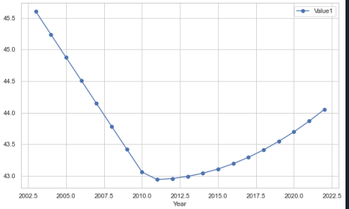  
Figure 1. Line Plot over the Years**

A line plot representing the trends for two variables, by accommodate numerical values, from 2003 to 2022 is shown in Figure 1. This displays a changing pattern over connecting data points, whereas Value 1 displays a progressive fall. The temporal variations with the two variables are clearly shown in this visualization.

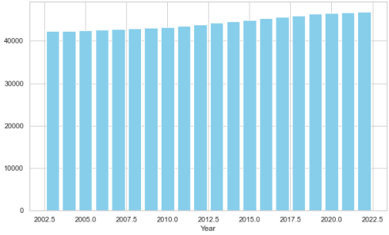

**Figure 2. Bar Plot over the Years**

The figure utilizes bar plot from 2003 to 2022 demonstrates a typically rising trend, from 42,277 for 2003 through 46,891 in 2022, the values increase gradually. This upward trajectory, which indicates a positive trend for the data, points to a steady growth pattern during the given period.

**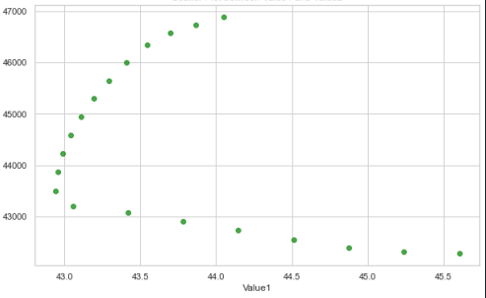  
Figure 3. Scatter Plot over the Years**

A scatter plot illustrating the connection between two variables over time is presented in Figure 3. The map graphically summarizes the changing pattern on the variables throughout the observed years as a function of changes in the listed country's climate dispersion of points reflects variability.

**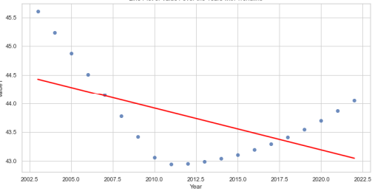  
Figure 4. Line Plot over the Years with Trendline**

Based on a dataset, the given Python code creates a variety of data visualizations, such as line, bar, scatter, and more in spyder. According to that, the numerical value can be effective as a line plot in Figure 4, with a trendline highlighting the general trend by data plot. The code analyses and visualizes data using pandas, seaborn, and matplotlib in an efficient manner.

**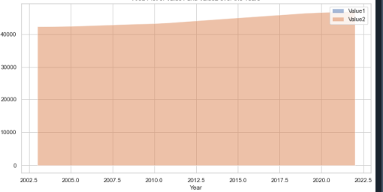  
Figure 5. Area Plot over the Years**

An area plot over a period is shown in Figure 5 to show the dynamics between both values. The graphic illustrates how the values changed and related to one another from specific year over climate data. The area plot facilitates simple data comprehension by succinctly and comprehensively visualizing the trends and fluctuations.

**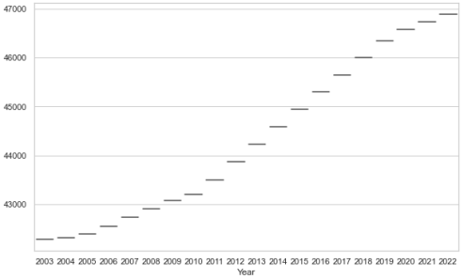  
Figure 6. Violin Plot**

Based on the above, violin plot showing the distribution for Value2 during the years 2003–2022 is shown in Figure 6. The plot highlights the patterns and variations in the dataset by displaying the variance and density of its values over years and the changing functionality of climate.

**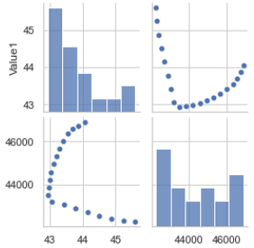  
Figure 7. Pair Plot over the Years**

The datasets that are offered span a range of numerical values from 2003 to 2022. A drop in one set of numbers (from 45.606 to 44.052, for example), variations across other variables, and possible linkages are important trends. The Pair Plot in Figure 7 provides a visual summary of the correlations between several variables across time, which facilitates in-depth trend analysis over the years in terms of climate variation.

**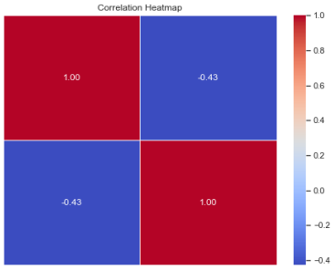  
Figure 8. Correlation Heatmap**

The represented figure contains routines for calculating bootstrap errors, kurtosis, and skewness. The provided data visualizations, which cover the years 2003 to 2022, show several patterns, including decreasing values, variable influences, as well as correlations. Figure 8, the correlation heatmap, provides important insights into data patterns by concisely illustrating the correlations between numerical columns across time.

**Conclusion**Based on the above descriptive analysis and represented visualizations, The datasets that are offered contain values in many categories and cover the years 2003 through 2022. The recorded numbers exhibit swings and patterns across this time frame, which might indicate future changes or advancements. Patterns and relationships are shown by the data visualizations, which include correlation heatmaps, line graphs, and bar charts. According to that, a comprehensive analysis necessitates a more profound comprehension of particular circumstances and elements impacting the noted varied patterns of climate changing of listed countries.

**Bibliography**Gu, Z., 2022. Complex heatmap visualization. *Imeta*, *1*(3), p.e43.

Chen, T., Liu, Y.X. and Huang, L., 2022. ImageGP: An easy‐to‐use data visualization web server for scientific researchers. Imeta, 1(1), p.e5.

Yu, Q. and Yuan, J., 2022. TransBigData: A Python package for transportation spatio-temporal big data processing, analysis and visualization. Journal of Open Source Software, 7(71), p.4021.